

***Operating Lease Support System Phase-2 Project***

***for***



***Functional Specification***

***FC.AB.4.4 Monitoring Complement Document***

Revision 0.1

**PT. Berlian Sistem Informasi**

KTB Annex Bld. 4th Floor, Jl. Jend. A. Yani. Pulomas,

Tel. +62 21 4786 7575 (Hunting) Fax. +62 21 4714964 www.bsi.co.id

Document Control

|  |  |
| --- | --- |
| **Author** | Raymond |
| **File Name** |  |
| **Path** |  |
| **Number of Page** |  |

Revision History

|  |  |  |  |
| --- | --- | --- | --- |
| **Date** | **Revision** | **Description** | **Author** |
| 1/10/2015 | 0.0 | Initialization | Raymond |
| 20/10/2015 | 0.1 | Updating Contents | Raymond |
|  |  |  |  |
|  |  |  |  |
|  |  |  |  |

Distribution List

|  |  |  |
| --- | --- | --- |
| Name | Organization | Roles |
| Mr. Jin Nishimura | Dipo Star Finance, PT | DSF Project Director |
| Mr. Shinji Hosokawa | Dipo Star Finance, PT | DSF Project Advisor |
| Mr. Ahmad Fikri | Dipo Star Finance, PT | DSF Project Advisor |
| Mr. Abdul Somad | Dipo Star Finance, PT | DSF Project Manager |
| Mr. Delta Riangga | Dipo Star Finance, PT | DSF Key User |
| Mr. Mochamad Idris | Dipo Star Finance, PT | DSF Key User |
| Mrs. Herni Hembang | Dipo Star Finance, PT | DSF Key User |
| Mr. Junaidi Didy | Dipo Star Finance, PT | DSF Key User |
| Mr. Dedi Supriyadi | Dipo Star Finance, PT | DSF Key User |
| Mrs. Elke Hilviana | Dipo Star Finance, PT | DSF Key User |
| Mr. Mukhlis Ibrahim | Dipo Star Finance, PT | DSF IT Department Representative |
| Mr. Roby Wijaya | Dipo Star Finance, PT | DSF IT Department Representative |
| Mr. Daiki Kamada | Berlian Sistem Informasi, PT | BSI Project Director |
| Mr. Feri Irawan | Berlian Sistem Informasi, PT | BSI Project Advisor |
| Mr. Grand Zah Putra | Berlian Sistem Informasi, PT | BSI Project Manager |
| Mr. Raymond | Berlian Sistem Informasi, PT | BSI Business Analyst |

Document Approval

By signing this document I acknowledge I have read the document and give the Project Management Team approval to proceed.

|  |  |  |  |
| --- | --- | --- | --- |
| Role | Name | Signature | Date |
| DSF Project Director | Mr. Jin Nishimura |  |  |
| DSF Project Advisor | Mr. Ahmad Fikri |  |  |
| DSF Project Manager | Mr. Abdul Somad |  |  |
| DSF IT Department Representative | Mr. Mukhlis Ibrahim |  |  |
| BSI Project Director | Mr. Daiki Kamada |  |  |
| BSI Project Advisor | Mr. Feri Irawan |  |  |
| BSI Project Manager | Mr. Grand Zah Putra |  |  |
| BSI Business Analyst | Mr. Raymond |  |  |

Table of Contents

Document Control 3

Revision History 3

Distribution List 4

Document Approval 5

1. Introduction 7

1.1 Purpose 7

1.2 Scope 7

1.3 Definition, Acronyms, and Abbreviations 7

1.4 References 7

2. Configuration 7

3. Detail Specification: FC.AB.4.4 Monitoring Complement Document 8

3.1. Purpose 8

3.2. Screen of Configuration Access 8

3.3. Screen Functionality 8

3.4. Operation Flow 8

3.5. Screen Design 9

3.6. Component Screen Functionality 10

3.7. Operation Description 11

3.8. Data Structure 13

1. Introduction
   1. Purpose

Functional Specification is a document to describe the detail of functions system which includes screen design, report, and logic formula. This document will be used for system development.

* 1. Scope

Functional Specification Document contains screen design, screen functionality, process flow, and data structure of FC.AB.4.4 Monitoring Complement Document for Phase-2.

Here are the scope for FC.AB.4.4 Monitoring Complement Document:

1. **AB.4.4.1 View Complement Document List**

To view document list from customer that needed for SKD Approval Process and Agreement Approval Process including status of completion.

Output from this document is:

1. PF.AB.4.4 Complement Document
   1. Definition, Acronyms, and Abbreviations
2. OPL = Operating Lease
3. DSF = Dipo Star Finance
4. BSI = Berlian Sistem Informasi
5. SKD = Surat Keputusan Direksi/ Board of Director’s Decree
   1. References

This functional specification document refers to **“To Be Design” AB. Marketing Process**, module:

1. AB.4 Marketing Operational Monitoring

* AB.4.4 Monitoring Complement Document

1. Configuration

* N/A

1. Detail Specification: FC.AB.4.4 Monitoring Complement Document
   1. Purpose

The Monitoring Complement Document screen is used by PIC Marketing Administration to view and update Complement Document from customers. This screen functions consist of view document compement list and update document complement status. Monitoring will be based on Agreement that has been created.

* 1. Screen of Configuration Access

Here are the access right for users:

|  |  |  |  |  |
| --- | --- | --- | --- | --- |
| ***User*** | ***Create*** | ***Read*** | ***Update*** | **Authorization** |
| PIC Markerting Administration | - | V | V | - |
| Marketing Officer | - | V | - | - |
| Head of Branch | - | V | - | - |
| Head of Department | - | V | - | - |
| Regional Manager | - | V | - | - |
| Advisor | - | V | - | - |
| Director | - | V | - | - |
| President Director | - | V | - | - |
| Shareholder’s Meeting | - | V | - | - |

Legend:

V = Have the access

* 1. Screen Functionality

1. View lists of Complement Document
2. Input status of Complement Document
3. Update status Complement Document
4. Print Complement Document
   1. Operation Flow

Below is operation flow for Monitoring and print unit preparation process refer to **To Be Design Document Marketing Process**, **AB.2.1 Board of Director’s Decree/ Surat Keputusan Direksi (SKD)**:

|  |  |
| --- | --- |
| **PIC PC** | **Process** |
|  | Agreement  (OPLAgreement)      Note:  Source  Output & Input    SKD  (Tb_MKT_DocComplement) |

* 1. Screen Design
* *Initial Screen Monitoring Complement Document for View, Input, Update and Print Complement Document*

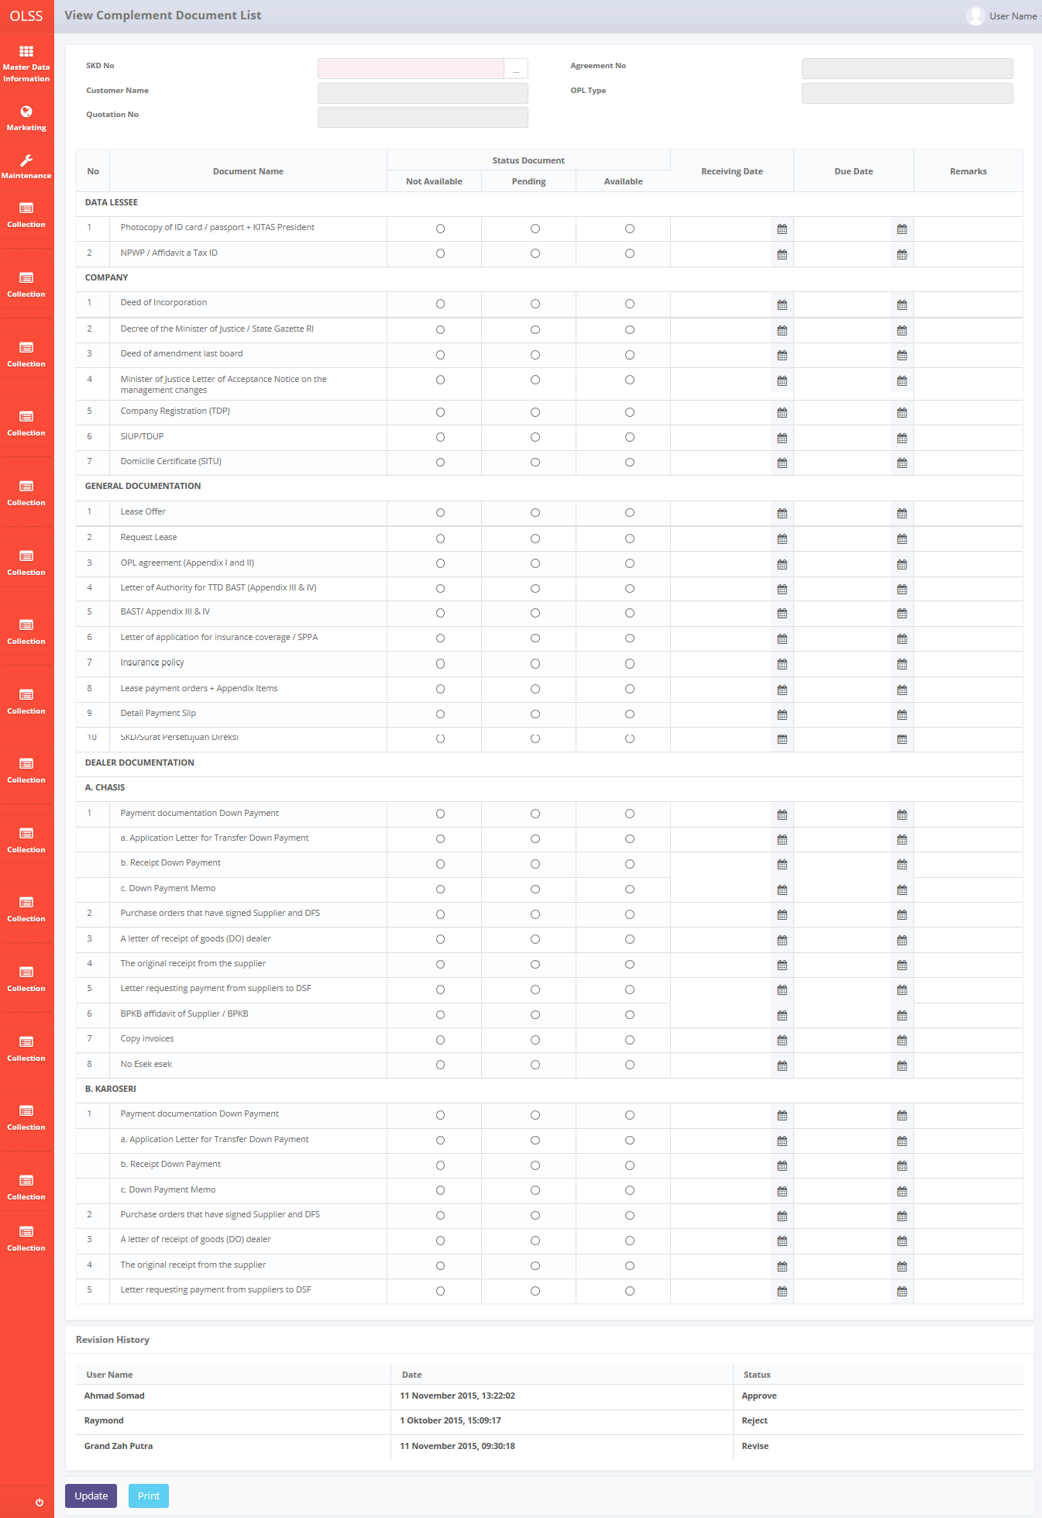

*Screen 1a. Monitoring Complement Document – LeaseBack*

* *Notification after click Update*



*Screen 2. Update Complement Document*

* 1. Component Screen Functionality
  2. **View Complement Document List**

Here are the screen functions from each component in **Screen 1. View Complement of Document List**:

|  |  |  |  |
| --- | --- | --- | --- |
| ***No*** | ***Component*** | ***Name*** | ***Function*** |
| **Header** | | | |
| 1 | Label | View Complement Document list | View Complement Document list title |
| 2 | Search Box | SKD No | To select SKD No |
| 3 | Text Box | Customer Name | Displaying Customer Name |
| 4 | Text Box | Quotation No | To show Quotation No |
| 5 | Text Box | Agreement No | Displaying Agreement No |
| 6 | Text Box | OPL Type | Displaying OPL Type |
| **Document List** | | | |
| 7 | Label | No | Displaying Number |
| 8 | Label | Document Name | Displaying Document list depends on Lease Category |
| 9 | Radio button | Status Document – Not Available | To declare Status Document – Not Available |
| 10 | Radio button | Status Document – Pending | To declare Status Document – Pending |
| 11 | Radio button | Status Document –Available | To declare Status Document – Available |
| 12 | Date Picker | Receiving Date | Displaying Receiving Date |
| 13 | Date Picker | Due Date | Displaying Due Date |
| 14 | Text Area | Remarks | To input remarks |
| Revision History | | | |
| 15 | Label | Revision History | Revision History Sub-Title |
| 16 | Label | User Name | Displaying User Name |
| 17 | Label | Date | Displaying Date |
| 18 | Label | Status | Displaying Status |
| Footer | | | |
| 19 | Button | Update | To update the complement document list |
| 20 | Button | Print Form | To print the form |

* 1. Operation Description

|  |  |  |
| --- | --- | --- |
| **No.** | **Operation Name** | **Description** |
| 1 | Initial view of View Complement Document List | The screen for list of Complement Document:   1. Component Status;  |  |  |  |  | | --- | --- | --- | --- | | Component | Name/Caption | Status | Remark | | Label | View Complement Document list | Active |  | | Search Box | SKD No | Active | Mandatory depicted in red | | Text Box | Customer Name | Not Active |  | | Text Box | Quotation No | Not Active |  | | Text Box | Agreement No | Not Active |  | | Text Box | OPL Type | Not Active |  | | Label | No | Not Active |  | | Label | Document Name | Not Active |  | | Radio button | Status Document – Not Available | Active |  | | Radio button | Status Document – Pending | Active |  | | Radio button | Status Document –Available | Active |  | | Label | Receiving Date | Not Active |  | | Label | Due Date | Not Active |  | | Text Area | Remarks | Not Active |  | | Button | Update | Active |  | | Button | Print Form | Active |  | |
| 2 | Input Complement Document List | Input:   1. Select the SKD Number from search box 2. Select the Status Document for each document item (Not available, Pending, or Available)   Constraint:   1. Default initial view, no Status Document is selected 2. User can only select one of Status Document 3. Input Receiving Date, Due Date, or Remarks (depending of choiches of Status Document) 4. Click Update button to update the document complement form   Process:   1. From step 1, the SKD Number will be generated from Tb_MKT_SKD.SKDNo. User will select the list shown from Tb_MKT_SKD 2. Selecting SKD Number will get data from Tb_MKT_SKD and OPLAgreement to fill the SKD Number field, Quotation No field, Customer Name field, Agreement No field, OPL type field, and populate the form with content from Tb_MKT_DocComplementList to choose the form template (fill the “Document Name” according to Tb_MKT_DocComplementList.LeaseCategory where Tb_MKT_DocComplement.idTb_MKT_SKD = Tb_MKT_SKD. idTb_MKT_SKD AND Tb_MKT_SKD.IdOPLQuotation = OPLQuotation.IdOPLQuotation AND OPLQuotation.IdOPLCalculation = OPLCalculation.IdOPLCalculation 3. From step 2, selecting each Status Document will activate each component  * Selecting “not available” will make “remarks” field to be active and must be filled before updating the form * Selecting “pending” will make “due date” field to be active and must be filled before updating the form * Selecting “available” will make “receiving date” field to be active and must be filled before updating the form  1. From step 4, the system will update the table Tb_MKT_DocComplement for each corresponding SKDNo 2. By clicking Update button, there will be notification “**Success!** Your data successfully updated” 3. Revision Log will be inserted with the User Name, Date and Status of the last activity from Tb_MKT_DocComplement_History   Status consists of:   * Update (when button Save as Draft or Save Changes is clicked) * Submit (when button Submit is clicked) * Check (when button Check is clicked) * Approve (when button Approve is clicked) * Reject (when button Reject is clicked) * Revise (when button Revise is clicked)   Output:   1. Data inserted into Tb_MKT_DocComplement |
| 3 | Update Complement Document List | Input:   1. Select the SKD Number from search box 2. Change the Status Document for each document item   Constraint:   1. User can only change the status with condition    * From “No status document” to “Not Available” or “Available” or “Pending”    * From “Pending” to “Available” or “Not Available” 2. User cannot change the status from “Available” to “Not Available” or “Pending” (The status document button disabled) 3. User cannot change the status from “Not Available” to “Available” or “Pending” (The status document button disabled) 4. Change Receiving Date   Constraint:   1. The Receiving Date cannot be updated after the 1st update (The status document button disabled) 2. Change Due Date, or Remarks 3. Click Update button to update the document complement form   Process:   1. From step 1, the SKD Number will be generated from Tb_MKT_SKD.SKDNo. User will select the list shown from Tb_MKT_SKD 2. Selecting SKD Number will get data from Tb_MKT_SKD and OPLAgreement to fill the SKD Number field, Quotation No field, Customer Name field, Agreement No field, OPL type field, and populate the form with content from Tb_MKT_DocComplementList to choose the form template (fill the “Document Name” according to Tb_MKT_DocComplementList.LeaseCategory where Tb_MKT_DocComplement.idTb_MKT_SKD = Tb_MKT_SKD. idTb_MKT_SKD AND Tb_MKT_SKD.IdOPLQuotation = OPLQuotation.IdOPLQuotation AND OPLQuotation.IdOPLCalculation = OPLCalculation.IdOPLCalculation 3. From step 4, the system will update the table Tb_MKT_DocComplement for each corresponding SKDNo 4. By clicking Update button, there will be notification “**Success!** Your data successfully updated” 5. Revision Log will be inserted with the User Name, Date and Status of the last activity from Tb_MKT_DocComplement_History   Status consists of:   * Update (when button Save as Draft or Save Changes is clicked) * Submit (when button Submit is clicked) * Check (when button Check is clicked) * Approve (when button Approve is clicked) * Reject (when button Reject is clicked) * Revise (when button Revise is clicked)   Output:   1. Data inserted into Tb_MKT_DocComplement |
| 4 | Print Complement Document | Input:   1. Operation Name 3. Update Complement Document List point 1-5 2. Click button Print   Process:   1. Operation Name 3. Update Complement Document List point 6 & 7   Output:   1. Print out form **PF.AB.4.4 Complement Document** |
| 3 | System error message | Process:   1. Any errors outside of application validation or that which cannot be handled by application such as errors when communicating with database, bugs, overloop, etc will generate an error message “System error. Please contact your administrator”   Output:   1. A page with system error message will appear. |

* 1. Data Structure

**Tb_MKT_DocComplement**

|  |  |  |  |  |  |  |
| --- | --- | --- | --- | --- | --- | --- |
| *Field Name* | *Data Type* | *Length* | *Source* | *Remarks* | *Nullable* | *Mandatory* |
| Primary Key View Complement Document | *Int* | *N/A* | Tb_MKT_DocComplement.IdTb_MKT_DocComplement | ***Primary Key*** | No | Yes |
| ID Complement Document List | *Int* | *N/A* | Tb_MKT_DocComplementList.IdTb_MKT_DocComplementList |  | No | Yes |
| ID SKD | *Int* | *N/A* | Tb_MKT_SKD.IdTb_MKT_SKD |  | No | Yes |
| ID OPL Agreement | *Int* | *N/A* | Tb_OPLAgreement.IdTb_OPLAgreement |  | No | Yes |
| Doc Status | *Int* | *N/A* | Tb_MKT_DocComplement.DocStatus |  | Yes | No |
| Receive Date | *Date* | *N/A* | Tb_MKT_DocComplement.ReceiveDate | *Format “mmddyyyy”* | Yes | No |
| Due Date | Date | N/A | Tb_MKT_DocComplement.DueDate | *Format “mmddyyyy”* | Yes | No |
| Remarks | *Varchar* | *100* | Tb_MKT_DocComplement.Remarks |  | Yes | No |
| Created By | *Varchar* | *20* | Tb_MKT_DocComplement.CreatedBy |  | No | Yes |
| Created Date | *Datetime* | *N/A* | Tb_MKT_DocComplement.CreatedDate | *Format “mmddyyyy hh:mm:ss”* | No | Yes |
| Last Modified By | *Varchar* | *20* | Tb_MKT_DocComplement.LastModifiedBy |  | Yes | No |
| LastModifiedDate | *Datetime* | *N/A* | Tb_MKT_DocComplement.LastModifiedDate | *Format “mmddyyyy hh:mm:ss”* | Yes | No |

**Tb_MKT_DocComplementList**

|  |  |  |  |  |  |  |
| --- | --- | --- | --- | --- | --- | --- |
| *Field Name* | *Data Type* | *Length* | *Source* | *Remarks* | *Nullable* | *Mandatory* |
| *Primary Key View Complement Document List* | *Int* | *N/A* | Tb_MKT_DocComplementList.IdTb_MKT_DocComplementList | ***Primary Key*** | No | Yes |
| Doc Category Code | *Varchar* | *20* | Tb_MKT_DocComplementList.DocCategoryCode |  | No | Yes |
| Doc Category Description | *Varchar* | *50* | Tb_MKT_DocComplementList. DocCategoryCode |  | Yes | No |
| Doc Name Code | *Varchar* | *20* | Tb_MKT_DocComplementList.DocNameCode |  | No | Yes |
| Doc Name Description | *Varchar* | *50* | Tb_MKT_DocComplementList. DocNameDescription |  | Yes | No |
| IsDelete | *Bit* |  | Tb_MKT_DocComplementList. IsDelete |  | No | Yes |
| RemarksSys | *Varchar* | *100* | Tb_MKT_DocComplementList.RemarksSys |  | Yes | No |
| Created By | *Varchar* | *20* | Tb_MKT_DocComplementList.CreatedBy |  | No | Yes |
| Created Date | *Datetime* | *N/A* | Tb_MKT_DocComplementList.CreatedDate | *Format “mmddyyyy hh:mm:ss”* | No | Yes |
| Last Modified By | *Varchar* | *20* | Tb_MKT_DocComplementList.LastModifiedBy |  | Yes | No |
| LastModifiedDate | *Datetime* | *N/A* | Tb_MKT_DocComplementList.LastModifiedDate | *Format “mmddyyyy hh:mm:ss”* | Yes | No |

* 1. Screen Item List

**PF.AB.4.4 Complement Document**

|  |  |  |  |
| --- | --- | --- | --- |
| *Content* | *Description* | *Source* | *Remarks* |
| Agreement No | Agreement No | OPLAgreement.AgreementNumber | *Where Tb_MKT_DocComplement.IdTb_OPLAgreement = OPLAgreement.IdOPLAgreement* |
| Customer Name | Customer Name | OPLAgreement.CustomerCode | *Where Tb_MKT_DocComplement.IdTb_OPLAgreement = OPLAgreement.IdOPLAgreement* |
| Supplier Name | Supplier Name | Supplier.IdSupplier | *Where Tb_MKT_DocComplement.IdTb_MKT_SKD = idTb_MKT_SKD.IdTb_MKT_SKD* ***AND*** *Tb_MKT_SKD.IdSupplier = Supplier.IdSupplier* |
| Unit | Unit | Tb_MKT_SKD_Dtl.Qty | *Where Tb_MKT_DocComplement.IdTb_MKT_SKD = idTb_MKT_SKD.IdTb_MKT_SKD* ***AND*** *Tb_MKT_SKD.* |
| No |  |  |  |
| Nama Dokumen |  |  |  |
| Complete |  |  |  |
| Y |  |  |  |
| N |  |  |  |
| R |  |  |  |
| Kondisi Dokumen |  |  |  |
| Action / Target |  |  |  |
| Disetujui Oleh |  |  |  |

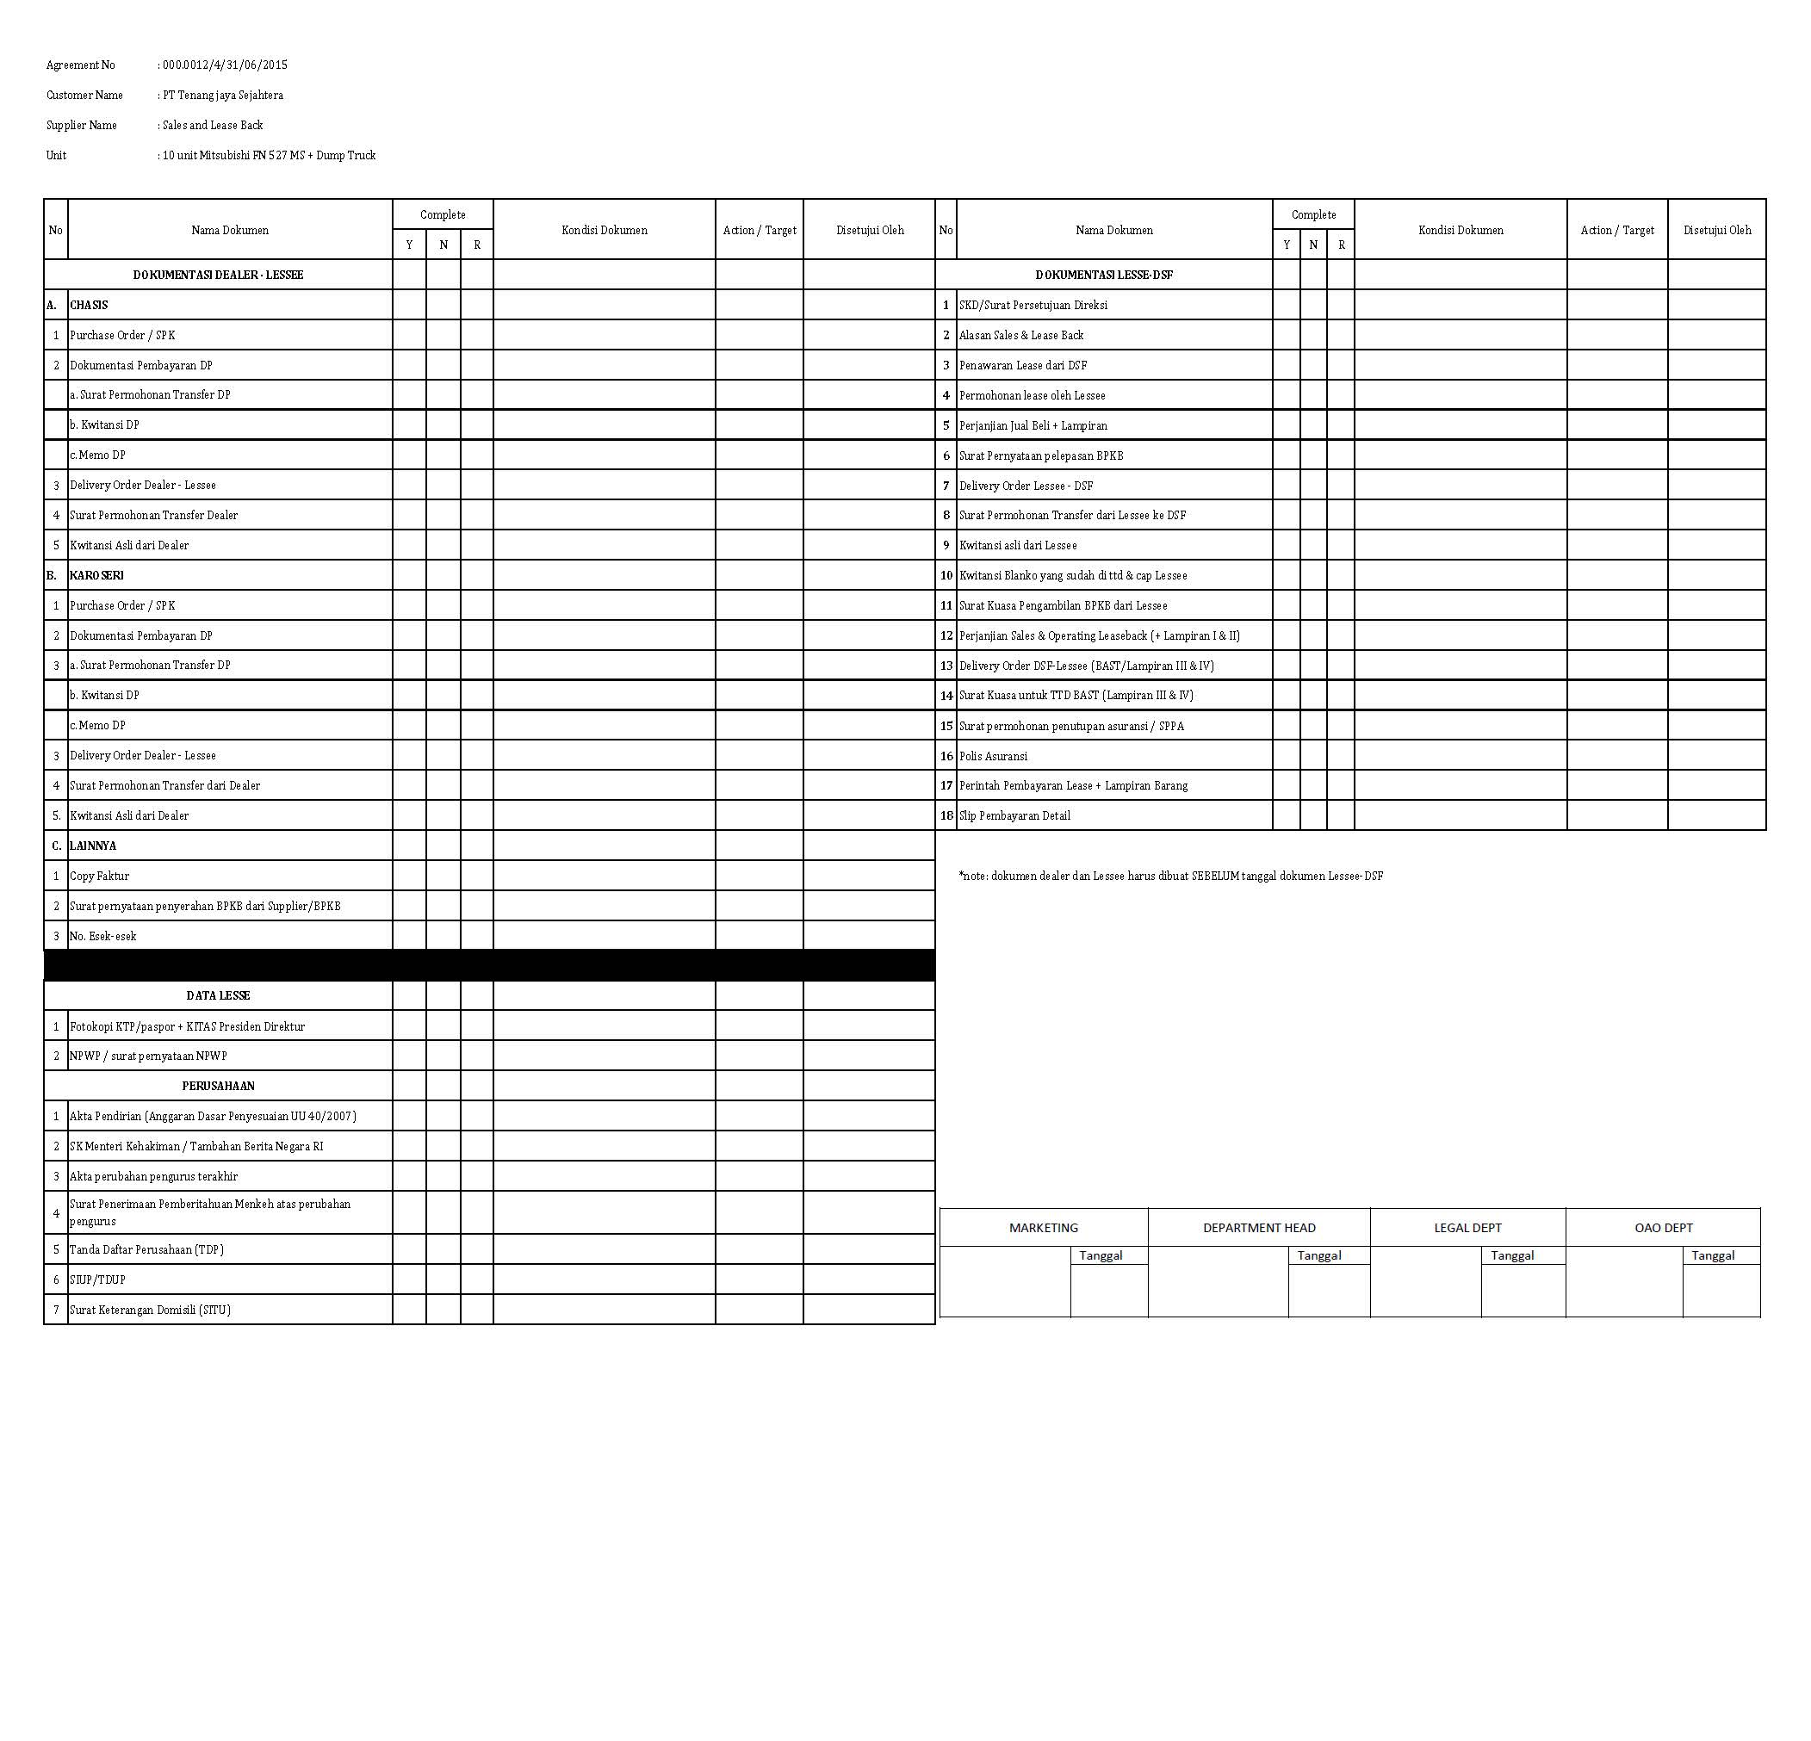

**APPENDIX - 1**

Configuration Access for Visit Customer Survey functions:

|  |  |  |  |  |  |  |  |
| --- | --- | --- | --- | --- | --- | --- | --- |
| **User** | **Branch** | **Functions** | | | | | |
| **Display List** | **Create** | **Edit** | **View** | **Print Form** | **Print Report** |
| Marketing Officer | One | V | V | V | V | V | V |
| Area |  |  |  |  |  |  |
| All |  |  |  |  |  |  |
| Head of Branch | One | V |  |  | V | V | V |
| Area |  |  |  |  |  |  |
| All |  |  |  |  |  |  |
| Head of Department | One |  |  |  |  |  |  |
| Area |  |  |  |  |  |  |
| All | V |  |  | V | V | V |
| Regional Manager | One |  |  |  |  |  |  |
| Area | V |  |  | V | V | V |
| All |  |  |  |  |  |  |
| Advisor | One |  |  |  |  |  |  |
| Area |  |  |  |  |  |  |
| All | V |  |  | V | V | V |
| Director | One |  |  |  |  |  |  |
| Area |  |  |  |  |  |  |
| All | V |  |  | V | V | V |
| President Director | One |  |  |  |  |  |  |
| Area |  |  |  |  |  |  |
| All | V |  |  | V | V | V |
| Shareholder's Meeting | One |  |  |  |  |  |  |
| Area |  |  |  |  |  |  |
| All | V |  |  | V | V | V |
|  |  |  |  |  |  |  |  |
| **Legend:** |  |  |  |  |  |  |  |
| V = Have the access |  |  |  |  |  |  |  |

**APPENDIX - 2**

**ERD Structure**

